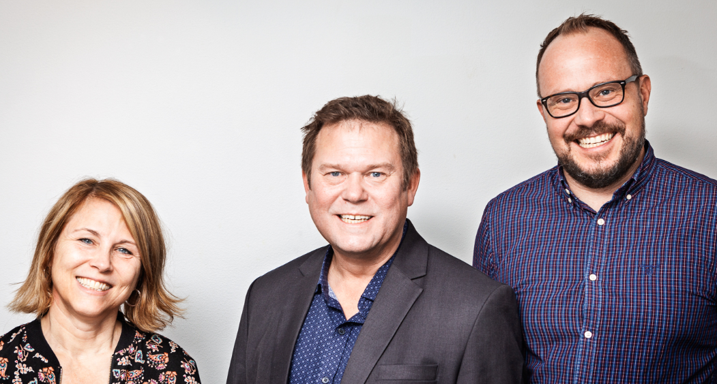
Contact
Jonas Berggren, M Sc MBA
+46 70-308 99 77
jonas.berggren@nhiab.com
Website
www.nhiab.com
www.healfy.se
IPR
NHI's technical solution is based on a cloud solution based on Microsoft Azure. NHI owns all intellectual property rights in the platform Healfy®.

Partnership/collaboration sought

We are looking for partners for expansion, nationally and internationally. As a partner we see, for example, med-tech companies that have an international contact network where our service can broaden their offering.

Capital need
We are looking for capital in the order of SEK 20 million divided into different phases. In the first phase, we need SEK 5 million. The first SEK 5 millon will be used for building organisation and sails in Sweden. Next steps will be international expansion with necessary further development of the solution.

Team/Scientific advisors
Jonas Berggren, CEO
Björn Sundqvist, Business Developer
Tina Berggren, Project Manager
Michal Rybka, Tech lead

Management/Board
Fredric Belin, Board Chairman
Jonas Berggren, CEO
Björn Sundqvist, Business Developer
Pontus Jämthag, Board Member

Background
NHI have developed a standardized scalable solutions in sparsely populated areas, if it works in this environments also work in urban areas. Now we are aiming for an national and international market.

Nordic Health Innovation – Healfy
the FUTURE OF DIGITAL HEALTHCARE

The individual can collect chosen medical data and interact with health care providers via different platforms through IoT (cloud solutions) in decentralized digital equipped health rooms or in their own home.
Market need and potential
The market need for more flexible, user friendly and cost efficient health care solutions is obvious and the time for modernizing health care using new digital technique, is now.
Sweden has within the project “God och nära vård, SOU 2019:29” started the transformation with changing the way to deliver health care service. NHI is working close to this project and we are implementing our solution in the structure and developing it further based on the users needs.
Information generated when an individual's health is measured is the basis for diagnosis and treatment. This is also a prerequisite for machine learning and AI. Many societies are going through demographic shifts with ageing populations, accumulating number of chronic disease patients and an accompanying increase in healthcare costs. In other parts of the world problems with high levels of infant and maternal mortality, may seem diametrically different, but can be solved by similar solutions.
Business idea
We develop, produce and deliver a standardized technical platform that enables flexible, cost-effective and quality assured health control and care at a distance. We do this by developing our solutions together with the healthcare providers and being a natural hub for the collective competence around tomorrow's health care systems and processes. Healthcare providers get access to an interface for recording medical measurement this enables them to be proactive instead of reactive. An intuitive interface enables individuals to take greater responsibility for their own health as they can take samples themselves and gain control over their own data.
The business model consists of two basic parts, license cost and a transactional fee for the usage.
Competition
The market is growing rapidly. Companies active in Sweden focus on offering services for the business to consumer market, and direct contact with a doctor by video technology. These solutions are not fit to handle the group of patients who need health care services the most and are the most resource intensive for society; elderly people with multiple deceases. NHI’s solution can be integrated in both existing health care systems and in infrastructures for other service providers.
Advantages
Health Care’s transformation towards digitization is driven by costs, customer requirements and technology development. NHI’s solution address this by:
- Ensuring that people who need medical services have better access to these services using new technology based on the IoT and cloud solutions.
- A new level of minimum effective care. The solution enables self-service and modern technology that reduces unnecessary visits at primary care and saves resources.
- Streamlining and modernizing medical services on the patients’ terms.
- Reducing costs for time, travel, transport and environmental impact.
Current status
NHI's solution Healfy is CE certified. We have several paying customers and we are working closely with them to adapt the solution to their needs and keep evolving the solution. We will soon conclude a project where Healfy has been tested for assisted measurements on patients in a retirement home, this could be a new paying customer segment. The cost-effective effects are clearly visible.

